Brainless
Online Learning System

BRAINLESS GROUP

Tittle: Brainless Online Learning System
Author: Rajat Vishwakarma, Sumit Kumar Singh , Sidhant Pandey , Shiv@nshu Mishra
Thesis Director: Rajat Vishwakarma
Date: 18/02/2018

Table Of Content

Table of Contents .................................................................................... 2

1.0 Introduction.......................................................4
1.1 Objective .......................................................... 4
1.2 Purpose of the Document .................................... 4
1.3 Overview .......................................................... 5
2.0 Course Template ................................................ 5
2.1 Digitization Template .......................................... 5
2.2 E-Learning Template ........................................... 5
3.0 Registration Process ............................................6
4.0 Software Requirement ......................................... 6
5.0 Specific Requirements ..........................................6
5.1 External Interface Requirements ........................... 6
5.2 User Inter face for the Course Template ................. 7
5.2.1 Digitization Course Template ..............................7
5.2.2 E-learning Course Template ............................... 7
5.3 Navigational Structure for End User ....................... 8
5.4 Hardware Interface Requirements ......................... 8
6.0 System Functionalities………................................... 8
6.1 Import and Organize media elements…………………………8
6.2 Synchronize the media elements………………………………..8
6.3 Preview………………………………………………………………………….8
6.4 Publish……………………………………………………………………….....8
7.0 Dataflow Diagram……………………………………………………..…..9
8.0 Non Functional Requirements………………………………………14
8.1 Performance Requirements………………………………………….14
8.2 Safety Requirements…………………………………………………….14
8.3 Security Requirements……………………………………………….…14
8.4 Quality Requirements…………………………………………………...14

9.0 Testing .................................................................14
10.0 Documentation .....................................................14
11.0 Contact Us……………………………………………….…………………...15

- 0 Introduction:-

1.1 Objective:-

This software aims to provide Online Learning System to BRAINLESS app Customers. Hence it seeks to publish the books through Internet in an electronic form with following two categories:

a) Digitization

Complete conversion of existing books into electronic format without any change in the content. The illustrations to be presented in enlarged view. Some video material can be fetch from official site links to illustrate easily.

b) E-Learning

Conversion of the books into Lessons to be designed using Animation, Text, voiceover, Graphics, Video etc.,
Both digitized content and e-Learning documents are to be made available in
the Internet. This software seeks to provide user friendly interface for the end
users with complete security to the contents of the documents in the internet.

1.2 Purpose of the Document:-

This document sets forth the baseline Functional requirements and detailed functional requirements of Brainless Online learning system. The requirements are designed explicitly with realism, execution process to undergo with the end user in mind.

1.3 Overview:-

The Online Learning System to be designed for web platform shall be
robust and scalable catering to the online users.
Digitization and E-learning
The digitization of the course material is to convert the complete book
available in print format to digital format. The content pages of the digitized course should conform to the standards specified in digitization template.
E-Learning is conversion of the lessons available in the form of printed books
into electronic format. The lesson to user shall be explained with on-screen text,
Illustrations, Animations and Video clips. Each course module should have
features like Navigational movement, text transcripts, Volume Control and
playing video clips.

The template consisting minimum essential functionalities for digitization and
e-learning, to be designed and developed. Templates to be designed should
ensure smooth flow of access and control to the courses.
these templates should provide all the necessary functionalities and
interface to handle the course content and easy user interface to the web
users and the administrators.

In addition to the above, following essential features shall be provided in the
proposed system:
a) Search option
1. To search within the Brainless app Web page.
2. Google search
b) Book Marking of lessons
c) Glossary
2.0 Course Template:-

The templates to be designed for both digitization and eLearning modules
should act as a container for the course content within the web application. Rainless group developing the e-learning course contents and digitization
course contents using these e-learning template and digitization templates
respectively. Hence, these templates should provide all the necessary
functionalities and interface to handle the course content and easy user
interface to the web users and the administrators.

2.1 Digitization Template:-

A template shall be designed for the digitization module and this will function
as a container for the digitized lessons.
All the courses to be developed should conform to the digitization template
standards and contents of the course should display within this template
window. The essential and minimal functionalities which are common for the
lessons and courses expected from the digitization templates are listed below:
- Window parameters like window height, width, background colour etc
- Minimizing and maximizing windows functions
- Navigation functionalities
- Enlargement of illustrations
- Book marking of the page
- Search options to search with in the current running course
- Functionalities to control the Video clips

2.2 E-Learning Template:-

This template to be designed for the eLearning courses that will function
as a container for the eLearning contents when displayed to the user. This
template should have following essential functionalities and controls for
Displaying Text
Animation
Lessons menu
Volume control
Mute control
Book mark
Navigation buttons
Replay of the animation
All the courses to be developed should conform to the eLearning template
standards and courses should run within this template window.

3.0 Registration Process:-

Once the new user is interested in the courses, he / she must be provided with
a registration form to fill their personal data. Proposed web application should use proper controls to accept the data from the user to minimize or avoid the
error in getting the data from the user. After successful registration, the user
should be acknowledged with a welcome message through an electronic mail.

4.0 Software Requirement:-

This section provides the information about the software requirement, an
abstract user interface with the system and functionalities involved.

5.0 Specific Requirements:-

5.1 External Interface Requirements:-

The Customized Course Management System is the integral part in
Communicating to the online user and administrator.
The minimal essential data to be captured are:
1. Title
2. Name
3. Date of Birth
A calendar control to fill the date of birth field shall be provided.
4. Email id
A text field shall be provided to capture the e-mail id of the user. This email –
id shall be used by the user to sign in into the system.
5. Password
A text field shall be provided to capture the password of the user; on
submission of the form the system should verify the authenticity. If the authenticity process fails, necessary user control and functionality shall be
provided to recall the user id and password.
On successful attempt of the Forgot Answer, the password shall be
automatically mailed to the user.

5.2 Administrator:-

This section is intended to provide detailed information about the
functionalities of the Administrator. The Administrator shall be provided
complete control of the entire online system.
The detailed Functionalities for the administrator are listed below:-
i. Administrator settings
ii. Course Management
iii. News Management
iv. MIS and Reporting
It shall have the facility to export customer and product data from the data base into
excel or PDF format.

5.3 User Inter face for the Course Template:-

This section provides the detailed requirement of the course template. Since
the courses are developed in two modes namely digitization and e-learning the
courses will be controlled by two course templates separately. The
functionality of the course templates are provided below:-

5.3.1 Digitization Course Template:-

Digitization Course Template will control the entire course content pages. The
template shall provide the following essential functionalities:-
i. Maximize and Minimize
ii. Complete Zoom in and Zoom out
iii. Enlarged view of the Illustrations
iv. Book Mark
v. Search
vi. Glossary
vii. Next Previous and Goto

5.3.2 E-learning Course Template:-

E-learning Course Template will control the entire course content namely,
animations, audio in addition to the navigation. The essential function of the
template is mentioned below:-
i. Listing and Selection of Lesson Menu
ii. Volume Control
iii. Mute
iv. Book Mark
v. Next – Previous
vi. Replay

5.4 Hardware Interface Requirements:-

Online learning system is a web-based application. A personal computer, with
internet connection, internet browser and Adobe Flash player.

6.0 System Functionalities:-

6.1 Import and Organize media elements:-

This software should be able to import video files, image files, HTML files and presentation slides specified by the user. Then the user should be able to organize these imported files over the time line and associate them with time and create cue points. It should then convert these media elements into compatible format.

6.2 Synchronize the media elements:-

These converted files should then be synchronized. The various files are synchronized with one another and also with the time line for generating a single output.

6.3 Preview:-

This software should allow the user to preview the presentation at any point when the presentation is being developed. It should have a preview tab selecting which would open the preview screen. The user can preview the presentation in this screen.

6.4 Publish:-

The E-Learning tool should generate a HTML page which would host the multi media presentation. It should make the HTML page and all the associated contents into a single compressed folder. The generated HTML page must be viewable in all web browsers.

7.0 Dataflow Diagram:-

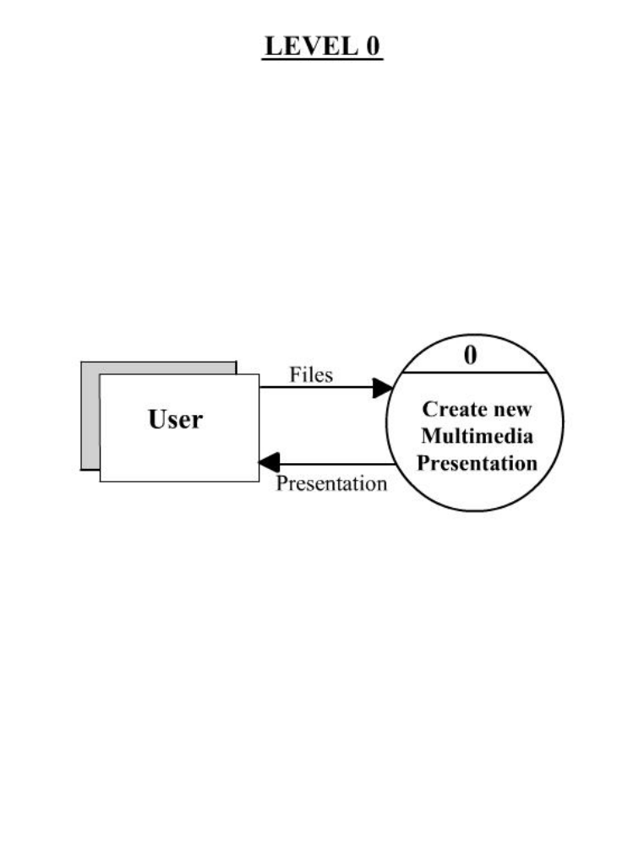
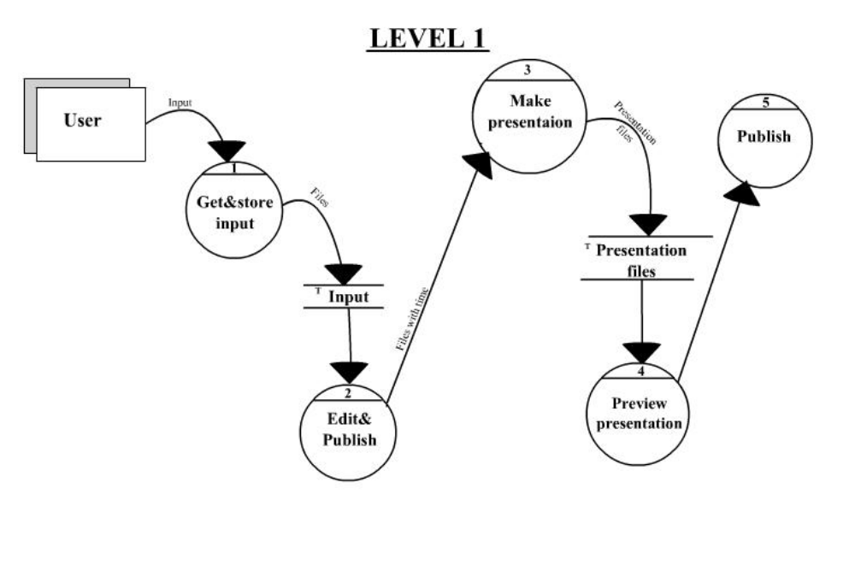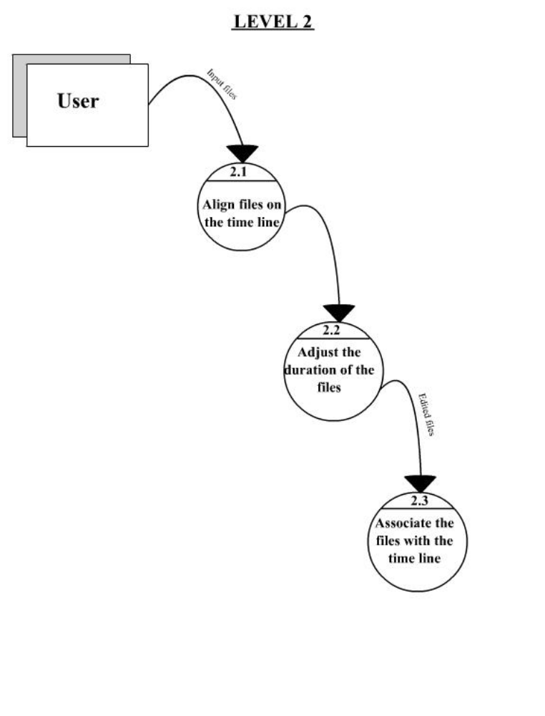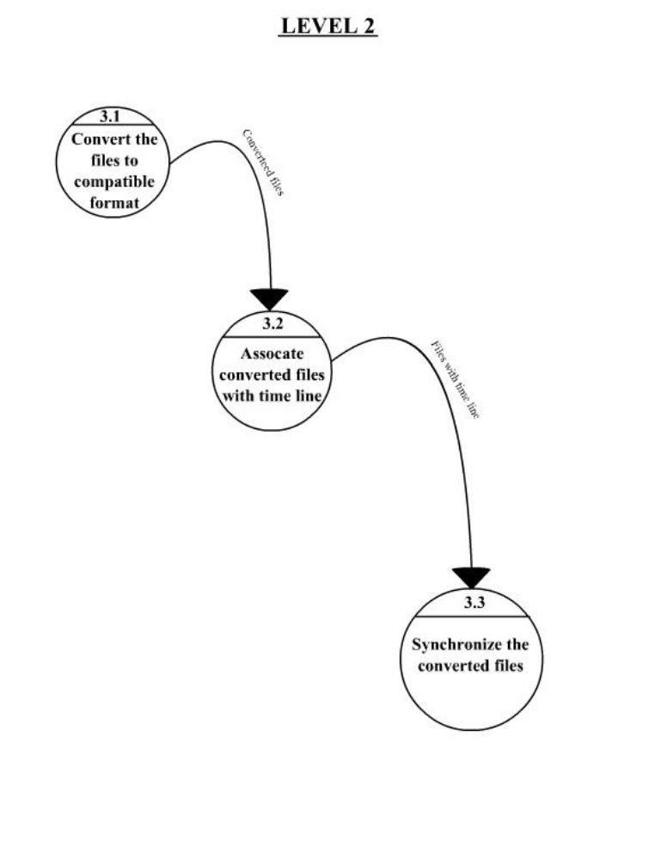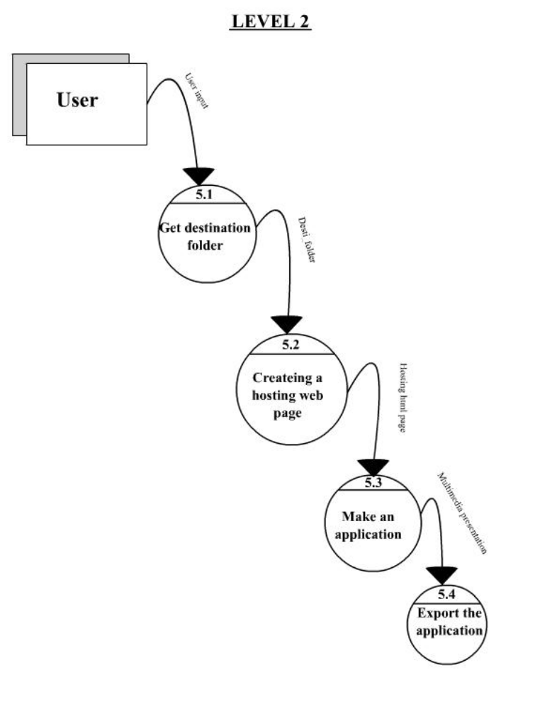

8.0 Non Functional Requirements:-

8.1 Performance Requirements:-

This software should perform the same way irrespective to its Operating System environments. Time taken for importing files and publishing the multimedia presentation should be minimum.

8.2 Safety Requirements:-

This requirement does not apply for our software as this is can’t pose a threat in no way.

8.3 Security Requirements:-

As all the operations are to be done within a single system security is not an issue for this software.

8.4 Quality requirements:-

Quality has a number of attributes some of the important attributes for this software are:-

- Portability:- As this software is to work on multiple platforms portability is an essential attribute and we ensure this by using JAVA as our programming language.

- User Training:- We assume that the users already have some previous experience in working with similar software’s. So the users will not need any specific training for using this software.

9.0 Testing:-

The web application shall be designed, developed and tested. All the test cases
shall be submitted to the Brainless group. The group will provide sample content for
digitization and e-learning testing. Successful vendor has to design a
digitization and e-learning module and submit to Brainless group.

10.0 Documentation:-

The web application proposed shall be properly commented at appropriate
places within the source code. A copy of Application Manual shall be supplied
to Brainless group.

11.0 Contact Us:-

Users should be given facilities to contact Brainless group through email. This should contain email id. Provision to send electronic mail shall be made available to the user.

